Question 2:

Solution)

Formulating the dual constraints and variables

Objective function (Max Z) = 80d1 + 60d2 + 70d3 - 100s1 - 120s2.

where

d1 = Price received at the warehouse 1. d2 = Price received at the warehouse 2. d3 = Price received at the warehouse 3. s1 = Price purchased at the plant A.

s2 = Price purchased at the plant B. subject to

d1 - s1 >= 622. d2 - s1 >= 614. d3 - s1 >= 630. d1 - s2 >= 641. d2 - s2 >= 645. d3 - s2 >= 649.

Question 3:

Solution)

Economic interpretation of dual

The goal of AEDs company is to reduce the total cost of production and shipment.

In order to accomplish that, the business should hire a logistics firm to handle the shipping. This firm will purchase the AEDs and ship them to various warehouses in an effort to reduce the total cost of production and shipping.

The constraints in the dual can be modified as d1 >= 622 + s1

d2 >= 614 + s1 d3 >= 630 + s1 d1 >= 641 + s2 d2 >= 645 + s2 d3 >= 649 + s2

This can be formulated as below MR >= MC

**Marginal Cost (MC)**: Marginal Cost refers to the additional cost that has been added as a result of increasing the amount.

**Marginal Revenue (MR):** The money made from selling the extra unit is referred to as marginal revenue.

For a profit, Marginal Revenue must be more than or equal to Marginal Cost. The following defines the plot between MR and MC.

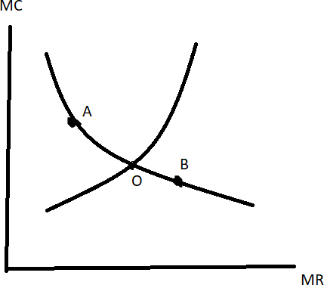

From the curve we see that at the point of intersection MR=MC and on moving the points to A or B i.e., MR>MC or MC<MR.

The optimal value cannot be reached at Points A and B. The dual problem's profit maximization is achieved at point O where MR = MC. For the primary problem, the cost is then minimized.